CSC424 Database Application Design Document Template

Project Name:

Project Team Members:

Creation Date:
Revision History:

This document is a template of design document designed for CSC424, Fall 2016.

1. Introduction

Purpose of this document
This is a design document…
It was realized by (project team?) for Project (project name)
Description of the business nature of this software application

2. Architecture Design

The architectural design is the design of the entire software system; it gives a high-level overview of the software system, such that the reader can more easily follow the more detailed descriptions in the later sections. It provides information on the decomposition of the system into modules (classes), dependencies between modules, hierarchy and partitioning of the software modules. Please use the multi-layer software application architecture suggested in the final project description.
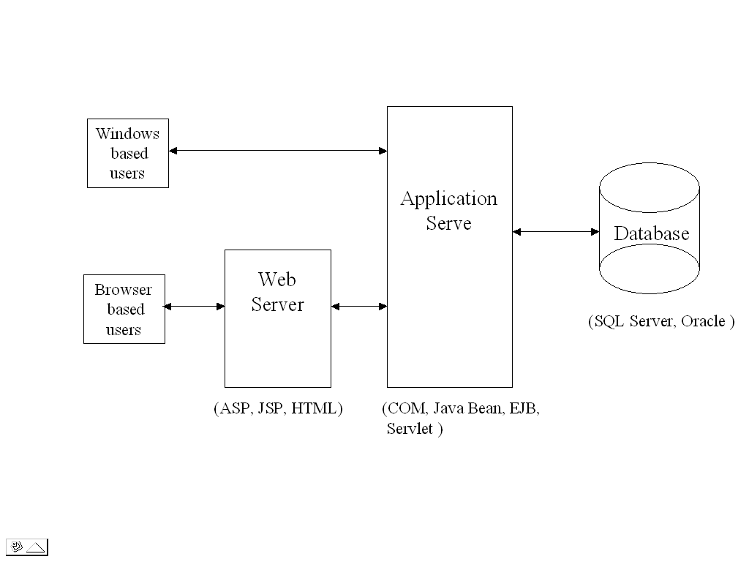

3. Database Design

The database design specifies how the date used by the software is going to be stored.

3.1 Entity-Relationship Diagram – Business Data Model

Use Entity-Relationship Diagram to model your business data.
.

3.2 Relational Data Model

This section contains all relations (known as table) information including relation names, attribute names for each relation and the primary key. The relational data model should be a faithful transformation from the E-R Diagram model (described in section 3.1) without lost of information and minimizing data redundancy.

All relation should follow the format shown in the example below:
Account (account-num, branch-name, balance)

3.3 Logical Schemas

The complete (compilable) set of CREATE TABLE statements (and other SQL statements) that declare the database schema, including integrity constraints, domain specifications, assertions, and access privileges -- documented in a template with the intended use of each table and column.

This is a recommended template you should use.

Name of the table
Description | This table describes…
Attribute | Description | Type | Examples of values
Id | Id of a student | Integer | Between 1 and 999999999
Name | Name of a student | String | John

Primary Key

Foreign Keys

Sample SQL Code

Here is a example using the recommended template:

Account
Description | This table describes customer saving account information.
Attribute | Description | Type | Examples of values
Account-num | Accouont ID | Integer | 9 digit between 000000001 and 999999999
Branch-name | Bank branch name where the account is opened | String | Main Street
Balance | Current saving | US currency | 23,345.00
Primary Key | Account-Number
Foreign Keys | Branch-Name
Sample SQL Code | Select * from account where balance > 10000

4. Graphical User Interface
- Provide, in an organized way, the pictures (screen shots) of all the forms in the graphical user interface with a reference to the functional requirement it implements. You may use Windows or Web forms to present the graphical user interfaces.
- For each form in the graphical user interface, provide:
  - The names of the controls and fields on that form,
  - The names of the events, methods, or procedures that cause that form to be displayed, and
  - The names of the events, methods, or procedures triggered by each control.
7. References

List of books, papers, URLs, tools that you consulted and used to design this document

8. Appendix

Hard copy or pointers to the documents that permitted you to assemble this document in collaboration with your client
Definitions of the important terms and acronyms used in the document.

You can use your own font, font style, font color… The document is not double-spaced.

